**Word of Life: November 2025**

*Recommended dates are provided, but you are welcome to use these materials at any time!*

**Featured this Month…**

**National Adoption Awareness Month**This occasion is an opportunity to highlight the gift of adoption. Resources are available to assist you in supporting and praying for all whose lives are touched by adoption:

* [An Adoption Love Story](https://www.respectlife.org/adoption-love-story)
* [Accompanying Expectant Mothers Considering Adoption](https://www.respectlife.org/mothers-considering-adoption)
* [Novena to St. Joseph: For Those on the Path of Adoption](https://www.respectlife.org/adoption-novena-resources)

**National Hospice and Palliative Care Month**This is a great opportunity to highlight the topics of hospice, palliative care, and other end-of-life issues. The following resources are available:

* [**Catholic Care for the Sick and Dying**](https://www.usccb.org/prolife/catholic-care-sick-and-dying)This webpage features prayers, articles, and educational resources to help Catholics bear Christ's love to those who are suffering from illness or dying.
* [**Word of Life: Parish Leader Kit – Catholic Care of the Sick and Dying**](https://www.usccb.org/resources/word-life-special-edition-catholic-care-sick-and-dying-parish-leader-kit)This special edition of the Word of Life offers a full list of resources surrounding end-of-life issues as well as sample intercessions, bulletin quotes, and graphics for use throughout the year.
* **Handout:** [**Resources on End of Life Care**](https://www.usccb.org/resources/usccb-resources-end-life-care)This two-page handout provides a listing of the most relevant resources on end-of-life care provided by the USCCB Secretariat of Pro-Life Activities.
* **Browse End-of-Life Resources in the** [**Respect Life Store**](https://store.respectlife.org/collections/end-of-life)Several resources are available in the Respect Life Store that highlight different issues at the end of life including: accompaniment, assisted suicide, advance directives, and more.



**The Solemnity of Our Lord Jesus Christ, King of the Universe   
November 23, 2025**  
[Resources are available](http://www.usccb.org/issues-and-action/religious-liberty/christ-the-king/index.cfm) to help educate the faithful about the Solemnity of Christ the King and its connection to religious liberty.

23

**Word of Life – November 2025**

**Intercessions for Life**

|  |  |
| --- | --- |
| **November 2nd**  For all Christians,  may we look forward to the resurrection of the dead  by preparing now, in hope,  for our passage from this life into eternal life,  *let us pray to the Lord.* | **The Commemoration of All Faithful Departed** |
| **November 9th**  For the sick, suffering, and those near death,  may they receive adequate care which embraces  their physical, psychological, and spiritual needs  as they journey toward eternal life,  *let us pray to the Lord.* | **Feast of the Dedication of the Lateran Basilica in Rome** |
| **November 16th**  For married couples considering adoption,  may the Holy Spirit guide their discernment,  grant them peace, and bring to fruition His holy will,  *let us pray to the Lord*: | **Thirty-third Sunday in Ordinary Time** |
| **November 23rd**  For all the faithful,  may the Lord help us build a culture of life  in vigilant expectation of His return,  *let us pray to the Lord*. | **The Solemnity of Our Lord Jesus Christ, King of the Universe** |
| **November 30th**  Inspired by the example of the Blessed Mother,  may we, like Mary, have the courage  to say “yes” to God’s gift of human life,  *let us pray to the Lord.* | **First Sunday of Advent** |

**Word of Life – November 2025**

**Bulletin Quotes**

|  |  |
| --- | --- |
| **November 2nd**  “Palliative care and hospice are precious and crucial instruments in the care of patients with serious and complex chronic or terminal illnesses, and they help provide comfort to both the patients and their families. While palliative care cannot entirely eradicate suffering from people’s lives, it provides an authentic expression of human and Christian care—allowing us to ‘remain’ at the side of a suffering person, as the Blessed Mother and the beloved disciple remained at the foot of the Cross…The path of accompaniment until the moment of death must remain open, with appropriate care for body and soul customized to the personal needs of the patient.”  USCCB Secretariat of Pro-Life Activities  “The Witness of the Good Samaritan: Palliative Care and Hospice” | [Download](https://www.usccb.org/resources/witness-good-samaritan-palliative-care-and-hospice) |
| **November 9th**  “In addition to enshrining pro-life laws and policies, the transformation of our culture also requires continual conversion of our *own* hearts, so that we can recognize in every person the face of Christ and place their needs before our own.”  Most Reverend Michael F. Burbidge, Chair of the USCCB Committee on Pro-Life Activities  “Living Radical Solidarity” | [Download](https://www.usccb.org/resources/2023-respect-life-month-statement)  [Online](https://www.usccb.org/resources/2023-respect-life-month-statement) |
| **November 16th**  “We can’t imagine loving a child whom we conceived more than we love Andrew. It is amazing how he fits our personalities so well… Adopting Andrew has made us more aware of God’s power and of his love for us. We realize that he always has a perfect plan for our lives.”  USCCB Secretariat of Pro-Life Activities,  “An Adoption Love Story” ([respectlife.org/adoption-love-story](https://www.respectlife.org/adoption-love-story)) | [Order](https://store.respectlife.org/collections/adoption/products/an-adoption-love-story) | [Download](https://www.usccb.org/resources/rlp-14-adoption-bullet-insert-eng.pdf)  Online |
| **November 23rd**  “Having received the gift of the Gospel of Life, we are the people of life and a people for life. It is our duty to proclaim the Gospel of Life to the world. To proclaim Jesus is to proclaim life itself. Gratitude and joy at the incomparable dignity of the human person impel us to bring the Gospel of life to the hearts of all people and make it penetrate every part of society.”  USCCB Secretariat of Pro-Life Activities “The Gospel of Life: A Brief Summary” | [Download](https://www.usccb.org/resources/rlp-20-bulletin-insert-ev-summary_0.pdf) | [Read Online](https://www.respectlife.org/gospel-of-life-summary)  [Online](https://www.respectlife.org/gospel-of-life-summary) |

**Word of Life - November 2025**

**Bulletin Art**

*You are welcome to use these and other downloadable images from the online* [**Respect Life image gallery**](https://www.respectlife.org/respect-life-image-gallery)*, provided they are not altered in any way, other than the size. Thank you!*

**Sunday, November 2nd, 2025**

**Article:** “[The Witness of the Good Samaritan: Palliative Care and Hospice](https://www.usccb.org/resources/witness-good-samaritan-palliative-care-and-hospice)”

**Image:** [English](https://www.usccb.org/sites/default/files/2022-10/sb-graphics-2_0.png) | [Spanish](https://www.usccb.org/resources/sb-graphics-2-spn_0.png)

**Sunday, November 16th, 2025**

* 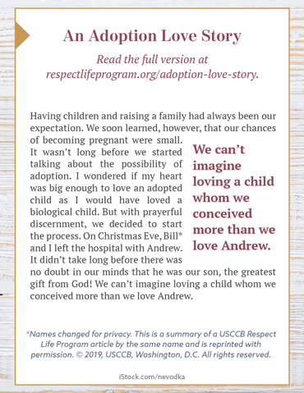**Image (Color):** [English](https://static.wixstatic.com/media/c138fd_501830b028e94988a3194a0cf2f25c6b~mv2_d_1275_1650_s_2.png/v1/fill/w_1275,h_1650/rlp-19-bulletinboxes-adoption-love-story.png) | [Spanish](https://static.wixstatic.com/media/c138fd_450c9454c6c14392a21ec93eea9caee2~mv2_d_1275_1650_s_2.png/v1/fill/w_1275,h_1650/rlp-19-bulletinboxes-adoption-spn.png)
* **Image (Grayscale):** [English](https://static.wixstatic.com/media/c138fd_b885ed7c069f4b1793b1b0683a9ceeb7~mv2_d_1275_1650_s_2.png/v1/fill/w_1275,h_1650/rlp-19-bulletinboxes-adoption-love-story-bw.png) | [Spanish](https://static.wixstatic.com/media/c138fd_f637ad169153461e989ff8d1cba3a048~mv2_d_1275_1650_s_2.png/v1/fill/w_1275,h_1650/rlp-19-bulletinboxes-adoption-spn-BW.png)
* **Quote Source:** [An Adoption Love Story](https://www.respectlife.org/adoption-love-story) (See bottom of the [webpage](https://www.respectlife.org/adoption-love-story) for additional formats.)

**Sunday, November 23rd, 2025**

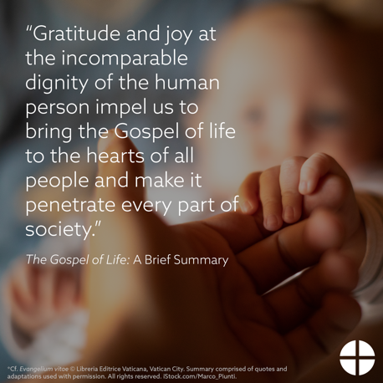**Article:** [*The Gospel of Life:* A Brief Summary](https://www.respectlife.org/gospel-of-life-summary)

**Image, Bulletin Insert PDF, and Word Doc**

<https://www.usccb.org/resources/gospel-life-brief-summary>